SŁÓWKA, ZWROTY I PIOSENKI POJAWIAJĄCE SIĘ NA
ZAJĘCIACH Z JĘZYKA ANGIELSKIEGO LUTY

GRUPA 3-4 LATKI | Piosenki na przywitanie/emocje/zabawy muzyczno-ruchowe.
Hello/  Good Moring/ Goodbye  Antonyms:  open-shut, big-small, fast-slow, long-short, loud-quiet, dirty-clean, high-low, hot-cold, wet-dry, old-young, soft-hard  Animals  Cow – krowa  Pig – świnia  Sheep – owca  Horse – koń  Fish- ryba  Mouse- mysz  Forest animals  Fox- lis  Deer-jeleń  Hedgehog-jeż  Wolf- wilk  Exotic animals  Monkey-malpa  Panda-panda  Tiger-tygrys  Giraffe-żyrafa  Lion-lew  - dog (pies) – barking “woof woof”  - cat (kot) – meowing “meow”  - cow (krowa) – mooing “moo”  - sheep (owca) – bleating “baa”  - horse (koń) – neighing “neigh”  - pig (świnia) – oinking “oink”  GRUPA 5- LATKI | Powitanie:  https://www.youtube.com/watch?v=fN1Cyr0ZK9M  Zabawy ruchowe:  Winter Freeze Dance  https://www.youtube.com/watch?v=5VQ_QpmHEfU  Open Shut them  https://www.youtube.com/watch?v=RNUZBHlRH4Y  The Opposites Song ~ Antonyms  https://www.youtube.com/watch?v=cwRddLXUnr8  The animal song  https://www.youtube.com/watch?v=wCfWmlnJl-A  Powtórzenie :  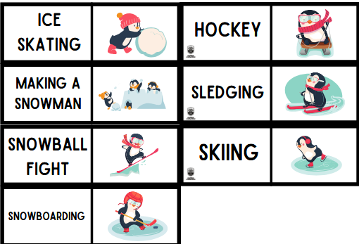  Winter:  snow, snowball, snowman, snowflake  reindeer, cold, snowballs, snowman, stars, snow
Hello/Bye  Good Moring/ Good afternoon  What's your name?  My name is...  How old are you?  I’m 5 years old.  Antonyms:  open-shut, big-small, fast-slow, long-short, loud-quiet, dirty-clean, high-low, hot-cold, wet-dry, old-young, soft-hard  Winter:  snow, snowball, snowman, snowflake  reindeer, cold, snowballs, snowman, stars, snow  Animals:  Cow – krowa  Pig – świnia  Sheep – owca  Horse – koń  Fish- ryba  Mouse- mysz  Donkey-osioł  Duck-kaczka  Forest animals:  Fox- lis  Deer-jeleń  Hedgehog-jeż  Wolf- wilk  Bear-niedźwiedź  Exotic animals:  Monkey-malpa  Panda-panda  Tiger-tygrys  Giraffe-żyrafa  Lion-lew  GRUPA 6- LATKI  Hello/Bye  Good Moring/ Good afternoon  What's your name?  My name is…  How old are you?  I’m 6 years old.  Emotions:  How are you?  I am…/ I feel:  happy, great, wonderful, tired, angry, sleepy, scared, sad, hungry, not so good  Nauka zadawania sobie pytań:  What’s your name?  How are you?  Antonyms:  open-shut, big-small, fast-slow, long-short, loud-quiet, dirty-clean, high-low, hot-cold, wet-dry, old-young, soft-hard  Animals:  Cow – krowa  Pig – świnia  Sheep – owca  Horse – koń  Donkey – osioł  Goat – koza  Llama – lama  Turkey – indyk  Duck – kaczka  Goose – gęś  Chicken – kura  Ox – wół  Bull – byk  Exotic animals:  Monkey – małpa  Gorilla – goryl  Panda – panda  Tiger – tygrys  Raccoon – szop pracz  Cheetah – gepard  Koala bear – miś koala  Kangaroo – kangur  Giraffe – żyrafa  Zebra – zebra  Hippopotamus – hipopotam  Rhinoceros – nosorożec  Crocodile – krokodyl  Lizard – jaszczurka  Lion – lew  Ostrich – struś  Whale – wieloryb  Dolphin – delfin  Forest animals:  Fox – lis  Bear – niedźwiedź  Squirrel – wiewiórka  Deer – jeleń  Hedgehog – jeż  Owl – sowa  Wolf – wilk  Butterfly – motyl  Hare – zając  Eagle – orzeł  Ant – mrówka  Beaver – bóbr  Stork – bocian  Wild boar – dzik  Badger – borsuk | Powitanie:  https://www.youtube.com/watch?v=fN1Cyr0ZK9M  Zabawy ruchowe:  Winter Freeze Dance  https://www.youtube.com/watch?v=5VQ_QpmHEfU  We All Fall Down | Walk Around The Circle Song | Super Simple Songs  https://www.youtube.com/watch?v=JRMAptlBgTk  Head Shoulders Knees & Toes (Speeding Up) | Nursery Rhyme | Super  Simple Songs https://www.youtube.com/watch?v=WX8HmogNyCY  Open Shut them  https://www.youtube.com/watch?v=RNUZBHlRH4Y  The Opposites Song ~ Antonyms  https://www.youtube.com/watch?v=cwRddLXUnr8  The animal song  https://www.youtube.com/watch?v=wCfWmlnJl-A  Powtórzenie :  Winter clothes  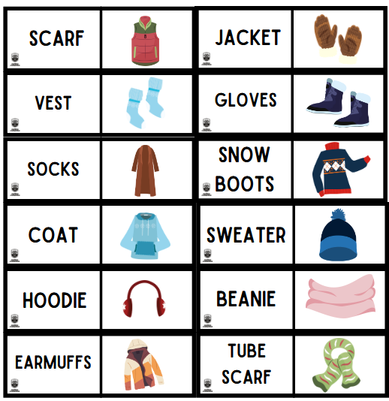  Bye, bye students.  Bye, bye teacher  Powitanie:  https://www.youtube.com/watch?v=fN1Cyr0ZK9M  Zabawy ruchowe:  Winter Freeze Dance  https://www.youtube.com/watch?v=5VQ_QpmHEfU  We All Fall Down | Walk Around The Circle Song | Super Simple Songs  https://www.youtube.com/watch?v=JRMAptlBgTk  Head Shoulders Knees & Toes (Speeding Up) | Nursery Rhyme | Super  Simple Songs https://www.youtube.com/watch?v=WX8HmogNyCY  Open Shut them  https://www.youtube.com/watch?v=RNUZBHlRH4Y  The Opposites Song ~ Antonyms  https://www.youtube.com/watch?v=cwRddLXUnr8  The animal song  https://www.youtube.com/watch?v=wCfWmlnJl-A  Zwroty:  - What’s your favourite animal?  - I like turtles.  - I love watching birds in the garden.  - Our hamster is sleeping in its little house.  - My sister is afraid of spiders.  - I have one dog and two cats.  - We have a fish tank with colourful fish.  - The eagle is flying high in the sky.  - Look at the dolphins in the ocean!  Powtórzenie :  Winter:  snow, snowball, snowman, snowflake  reindeer, cold, snowballs, snowman, stars, snow  Bye, bye students.  Bye, bye teacher

