SŁÓWKA, ZWROTY I PIOSENKI POJAWIAJĄCE SIĘ NA
ZAJĘCIACH Z JĘZYKA ANGIELSKIEGO STYCZEŃ

GRUPA 3-4 LATKI | Piosenki na przywitanie/emocje/zabawy muzyczno-ruchowe.
Hello/  Good Moring/ Goodbye  I can jump!  run, jump, sit down, stand up, turn around  tomp", "clap", "dance", "wiggle", "jump",  "spin"  Can you clap your hands like me? Can you wiggle like me? Can you  dance like me and with me? Let's dance!  Winter:  snow, snowball, snowman, snowflake  reindeer, cold, snowballs, snowman, stars, snow  Winter fun:  footprints, play snowball fight,angel snow,ice skating, go sledding  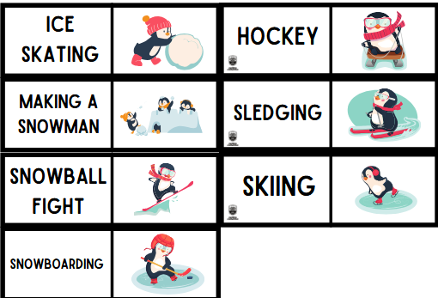  GRUPA 5- LATKI | Powitanie:  https://www.youtube.com/watch?v=fN1Cyr0ZK9M  Make a circle up, up, up  down, down, down, up, up, up  Make a circle down, down, down  Now, sit down.  Zabawy ruchowe:  Winter Freeze Dance  https://www.youtube.com/watch?v=5VQ_QpmHEfU  Put On Your Boots | Kids Songs | Super Simple Songs  - https://www.youtube.com/watch?v=AsZwvuUmHGU  "Stomp Clap Dance" The Kiboomers https://www.youtube.com/watch?v=XM7Jnetdf0I  Powtórzenie :  Christmas,  Santa Claus, present, Christmas tree, bells, angel  Bye Bye Goodbye | Goodbye Song for Kids | Super Simple Songs -  https://www..com/watch?v=PraN5ZoSjiY  Bye, bye students.  Bye, bye teacher
Hello/Bye  Good Moring/ Good afternoon  What's your name?  My name is...  How old are you?  I’m 5 years old.  Nauka zadawania sobie pytań:  What’s your name?  How do you feel today?  Counting:  1-15  How many girls/boys are in our circle?  I can jump!  run, jump, sit down, stand up, turn around  Winter:  snow, snowball, snowman, snowflake  reindeer, cold, snowballs, snowman, stars, snow  Winter clothes  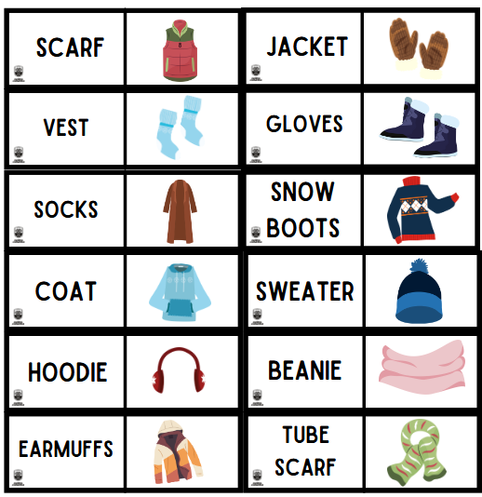  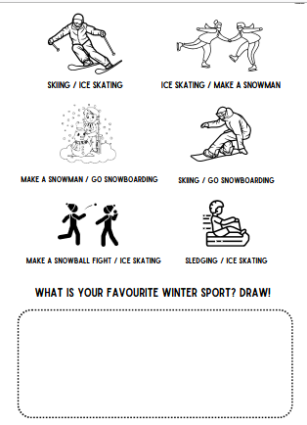  Winter fun:  footprints, play snowball ,angel snow ice skating, go sledding  Winter clothes  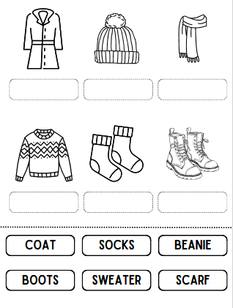  GRUPA 6- LATKI  Hello/Bye  Good Moring/ Good afternoon  What's your name?  My name is…  How old are you?  I’m 6 years old.  Emotions:  How are you?  I am…/ I feel:  happy, great, wonderful, tired, angry, sleepy, scared, sad, hungry, not so good  Nauka zadawania sobie pytań:  What’s your name?  How are you?  Antonyms:  open-shut, big-small, fast-slow, long-short, loud-quiet, dirty-clean, high-low, hot-cold, wet-dry, old-young, soft-hard  Counting:  1-20  How many girls/boys are in our circle?  Winter:  snow, snowball, snowman, snowflake  reindeer, cold, snowballs, snowman, stars, snow  winter, cold, snowballs, snowman, stars, snow, gingerbread man  Winter fun:  footprints, play snowball fight,angel snow,ice skating, go sledding  I can jump!  run, jump, sit down, stand up, turn around  run, jump, sit down, stand up, turn around, smile, shake hands  Can you (jump / stand up / … )?; I􀁢can (jump / stand up / … ); I􀁢can’t  (run / jump / … ); Let’s (jump / sit down / … ); Don’t (turn around /  mo􀁙e / … ) | Powitanie:  https://www.youtube.com/watch?v=fN1Cyr0ZK9M  Make a circle up, up, up  down, down, down, up, up, up  Make a circle down, down, down  Now, sit down.  Zabawy ruchowe:  Winter Freeze Dance  https://www.youtube.com/watch?v=5VQ_QpmHEfU  Put On Your Boots | Kids Songs | Super Simple Songs  -  https://www.youtube.com/watch?v=AsZwvuUmHGU  Can you put on your beanie?  Can you put on your coat?  "Stomp Clap Dance" The Kiboomers https://www.youtube.com/watch?v=XM7Jnetdf0I  ( I Can Jump! | Actions Song for Kids | Fun Kids English - YouTube  an you (Jump / stand up / …)?; I can (jump / stand up / … ); I can’t (run / jump / … ); Let’s (jump / sit down / …); Don’t (turn around / move / …).  We All Fall Down | Walk Around The Circle Song | Super Simple Songs  https://www.youtube.com/watch?v=JRMAptlBgTk  I lke winter | Season Song for Kids  https://www.youtube.com/watch?v=ODsirjqEuzQ  :  We can make a snowman.  We can have a snow fight.  We can skate on the ice.  We can ride a snow sleigh.  Move" SuperSimpleSongs: https://www.youtube.com/watch?  v=xNw1SSz18Gg.  Head Shoulders Knees & Toes (Speeding Up) | Nursery Rhyme | Super  Simple Songs https://www.youtube.com/watch?v=WX8HmogNyCY  Powtórzenie :  Merry Christmas!  Christmas, Santa Claus, present, Christmas tree, bells, angel, elves,  Bye Bye Goodbye | Goodbye Song for Kids | Super Simple Songs -  https://www..com/watch?v=PraN5ZoSjiY  Bye, bye students.  Bye, bye teacher  Powitanie:  https://www.youtube.com/watch?v=fN1Cyr0ZK9M  Make a circle up, up, up  down, down, down, up, up, up  Make a circle down, down, down  Now, sit down.  Zabawy ruchowe:  Winter Freeze Dance  https://www.youtube.com/watch?v=5VQ_QpmHEfU  Put On Your Boots | Kids Songs | Super Simple Songs  -  https://www.youtube.com/watch?v=AsZwvuUmHGU  Can you put on your beanie?  Can you put on your coat?  "Stomp Clap Dance" The Kiboomers https://www.youtube.com/watch?v=XM7Jnetdf0I  ( I Can Jump! | Actions Song for Kids | Fun Kids English - YouTube  an you (Jump / stand up / …)?; I can (jump / stand up / … ); I can’t (run / jump / … ); Let’s (jump / sit down / …); Don’t (turn around / move / …).  We All Fall Down | Walk Around The Circle Song | Super Simple Songs  https://www.youtube.com/watch?v=JRMAptlBgTk  I lke winter | Season Song for Kids  https://www.youtube.com/watch?v=ODsirjqEuzQ  :  We can make a snowman.  We can have a snow fight.  We can skate on the ice.  We can ride a snow sleigh.  Move" SuperSimpleSongs: https://www.youtube.com/watch?  v=xNw1SSz18Gg.  Head Shoulders Knees & Toes (Speeding Up) | Nursery Rhyme | Super  Simple Songs https://www.youtube.com/watch?v=WX8HmogNyCY  Zwroty:  t's bitterly cold outside today.  You must wrap up warm  Don't forget your earmuffs, they'll keep your ears warm.  Why aren't you wearing your gloves / mittens  Your hands are freezing.  It's so slippery today. You really have to watch your step.  It's sleeting. Half frozen rain is not pleasant.  Powtórzenie :  Merry Christmas!  Christmas, Santa Claus, present, Christmas tree, bells, angel, elves,  Bye Bye Goodbye | Goodbye Song for Kids | Super Simple Songs -  https://www..com/watch?v=PraN5ZoSjiY  Bye, bye students.  Bye, bye teacher

